**Smart Contract based Land Registration System Using Blockchain**

Dr. P. Rathna Sekhar, P. Bharath Reddy, P. Rohan, P. Yuvatarak

*Assistant Professor, Department of Computer science and Engineering, Anurag University, Hyderabad, Telangana – 500088, India.*

*Department of Computer science and Engineering, Anurag University, Hyderabad, Telangana – 500088, India.*

*Department of Computer science and Engineering, Anurag University, Hyderabad, Telangana – 500088, India.*

*Department of Computer science and Engineering, Anurag University, Hyderabad, Telangana – 500088, India.*

[*rathnasekhar.cse@anurag.edu.in*](mailto:rathnasekhar.cse@anurag.edu.in)

[*21eg105c39@anurag.edu.in*](mailto:21eg105c39@anurag.edu.in)

[*21eg105c40@anurag.edu.in*](mailto:21eg105c40@anurag.edu.in)

[*21eg105c44@anurag.edu.in*](mailto:21eg105c44@anurag.edu.in)

**ABSTRACT**

Blockchain is a database that records transactions on many computers. It is a decentralized technology, so all the copies of the blocks are distributed in a network. This solution will remove the problems that exist in the traditional system. The old system has many issues. We still use the conventional registration system, where a broker is between buyer and seller. And he is responsible for all transactions and document verification. The broker will guarantee that the documents are registered with an approved government office, where all the property-related information is kept in a public digital ledger, and the transaction between the two parties takes place. However, anyone with authorization to access these papers may lose, replace or modify them, which risks the protection of property and lands. Blockchain enables us to construct a digital ledger of transactions, events and data secured by a cryptographic algorithm.

**Problem Statement**

The simple meaning of land/property registration is to store the true ownership details respectively or transfer the ownership from seller to buyer along with the total verification. It is quite true that the property or land will not perish, but the owner, who is a person, can. So we need a persistent record mandatorily to track the true ownership of a land/property along with its past transfer history. Blockchain allows the end-user to keep all records unchanged and updates related to specific records.

**Existing System:**

Land registration involves collection of details like ownership and size of the property. Currently the entire process of land registry maintenance is too tedious since it involves safekeeping of large volumes of registers in written form. The main issue with the above-mentioned method of land registry maintenance is that any future reference that needs to be taken from these hard copies will involve too much labour. This process is time consuming. Current system is not secure since majority of the process is not transparent, system is slow, and selling a property more than once needs to be recorded accurately. Several approaches have been made to automate the land registry data maintenance by eliminating the process of keeping bookish records. This is initially done by storing the data in huge databases. But such a method is not efficient in terms of data security as the data contents are breached easily as data tampering can happen in case of poorly maintained databases.

**Disadvantages:**

* Current systems are not secure since majority of the process is not transparent.
* The data can breach easily as data tampering can happen in case of poorly maintained databases.

**Proposed Methodology:**

**1. Account Verification**

* Buyers & Land Owners register on the platform.
* Admin verifies the accounts to ensure only legitimate users can proceed.

**2. Land Registration**

* Land Owners register their land by providing details.
* Admin verifies the land details to check ownership authenticity.

**3. Buying Request**

* Buyers browse registered lands and send a buying request to the Land Owner.

**4. Approval of Buyer’s Request**

* Land Owner reviews the request and approves or rejects it.

**System Requirements**

**Hardware Requirements**

|  |  |
| --- | --- |
| RAM | 4 GB Minimum |
| Processor | i4 Minimum |
| Hard disk | 500 GB HDD Min |

**Software Requirements**

|  |  |
| --- | --- |
| Technology | Python 3.12 |
| Operating System | Windows Family |
| IDE | VS Code |
| Technology | Python, Django |
| Database Server | MySQL |
| Front Design Technology | HTML, CSS, JS |

**INTRODUCTION**

Blockchain technology was founded by the scientist Stuart Haber and W. Scott Stornetta in 1991. They developed this system using a cryptographic chain of blocks. Satoshi Nakamoto introduced Bitcoin in 2008, a type of digital currency that uses cryptographic concepts. Bitcoin is part of the broader scope of cryptocurrency and has become the most valuable digital currency in this era. Blockchain is a new platform for creating decentralized applications and storing data among shared parties, keeping a record of all transactions. Transactions in the public ledger are validated using consensus processes, which involve most of the system's members. Each time a new transaction occurs, a fresh data block is produced and encrypted using a hashing method. Blockchain allows the construction of a secure record of transactions, events, and data protected by advanced cryptographic safeguards. For immutability and tamper-proofing, this log is distributed and replicated across the network. Blockchain enables a single block of data to expand as new blocks are appended, with each block containing transaction records in a carefully structured format. These blocks are linked cryptographically, ensuring security. Using the SHA-256 algorithm, a unique hash code is generated. Blockchain maintains a secure, transparent, and immutable ledger of asset-related information that cannot be manipulated.

**IMPLEMENTATION**

**1.Account Verification**

Ensure only verified and legitimate users participate in the system.

1. Buyers & Land Owners Register
2. Users (Land Owners & Buyers) create an account by providing necessary details such as name, email, government-issued ID, and contact information.
3. Passwords are securely hashed and stored to maintain security.
4. Admin Verifies the Accounts
5. The admin reviews user details and checks if the provided documents (like Aadhar, PAN, or land ownership proof) are valid.
6. Only verified users gain access to the system to register or buy land.
7. Once verified, the user gets a unique ID (stored on the blockchain) for secure identification.

**2. Land Registration**

1. Land Owners Register Their Land

Landowners submit land details, such as:

* Land location (latitude/longitude)
* Land size (square feet)
* Ownership documents
* Price and description

1. Admin Verifies the Land Details

* The admin checks the documents to confirm the land belongs to the registered owner.

**3. Buying Request**

Buyers Browse Registered Lands

Buyers search for available lands based on:

* Location
* Price range
* Size

They can view all verified land details but cannot modify them.

Buyers Send Buying Requests

When a buyer is interested in a specific land, they send a request to the landowner.

The request is recorded as a transaction on the blockchain for transparency.

**4. Approval of Buyer’s Request**

Land Owner Reviews the Request

* The landowner receives the request and reviews the buyer's details.
* Land Owner Approves or Rejects the Request.

**Technical Feasibility**

Technical resources need for project Development

* Windows family Operating System
* Python 3.12 Technology
* Vs Code
* Mysql

**Functional Requirements**

**Admin**

Login

Verify Accounts

Land details verification

**Land Owners**

Signup

Login

Register Land

Approve Buyer' request

**Buyers**

Signup

Login

View registered land details

buying request

**Formatting Figures:**

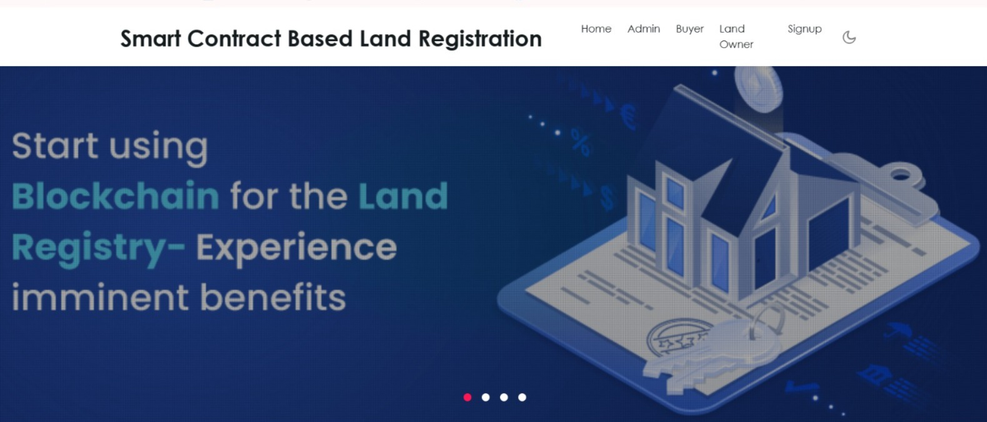

Fig 1:Home Page

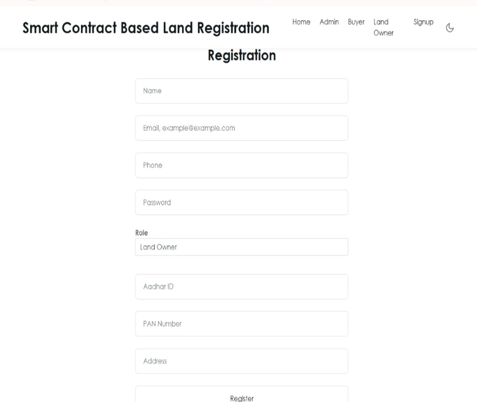

Fig 2:buyer/seller registration

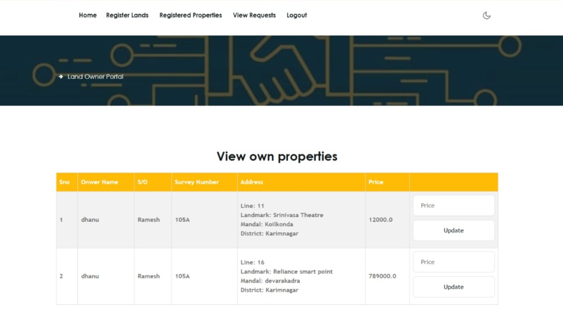 Fig 3: Land Owner Portal

**CONCLUSION**

We successfully provide a solution to our existing problem we suggest a solution that takes advantage of the concept of smart contracts, which is a self-consensus code contained in blockchain technology. This eliminates the need for third parties and streamlines the registration process. Smart contracts are deployed using distributed servers like the Ethereum public blockchain server. This code outlines the regulations that all parties participating in the land registration process must follow. Due to decentralization, no single entity manages these contracts; instead, they are dispersed throughout a common database shared by many systems. As a result, they need to have control over the information. In other words, it's almost impossible to hack.

**Study Limitations**

Dependence on Internet and Digital Infrastructure – Successful implementation requires stable internet connectivity and digital literacy, which may be limited in rural or underdeveloped areas.

**Acknowledgements**

We would like to express our sincere gratitude to Anurag University for their unwavering support throughout this project. Special thanks go to Dr . P . Rathna Sekhar Sir, Assistant Professor in the Department of Computer Science and Engineering, for his invaluable guidance and supervision. We also acknowledge the assistance provided by our colleagues and friends for their feedback and encouragement during the development of this project. Their contributions have been instrumental in the successful completion of the "Smart Contract based Land Registration System Using Blockchain”.

1.4 **Funding source**: None

1.5 **Competing Interests**: None

**REFERENCES**

[1] Satoshi Nakamoto, Bitcoin: A peer-to-peer electronic cash system, 2008. Available: https://bitcoin.org/bitcoin.pdf.

[2] N.S.Tinu(2018), A Survey on Blockchain Technology Taxonomy, Consensus Algorithms and Applications. Vol.-6, 5, May 2018, E-ISSN: 2347-2693.

[3] Madakam S., &Kollu S. Blockchain Technologies Fundamentals Perceptions, Principles, Procedures and Practices. Journal of Social and Management Sciences, Vol. 48, Iss. 4, (Jan-Mar 2020): 345-368.

[4] Victoria Lemieux “Blockchain and Distributed Ledgers as Trusted Record keeping Systems: An Archival Theoretic Evaluation Framework”. Future Technologies Conference 2017: Vancouver, BC, Canada 17 Nov 2017.

[5] Harry Halpin, Marta Piekarska "Introduction to Security and Privacy on the Blockchain", 2017 IEEE European Symposium on Security and Privacy Workshops (EuroS&PW).

[6] WajdeBaiod, Janet Light, Aniket Mahanti(2021), Blockchain Technology and its Applications Across Multiple Domains, Journal of International Technology and Information Management Vol-29 Issue 4, 4 2021.

[7] Meghali Nandi, Rajat Kanti Bhattacharjee, Amrit Jha, Ferdous A. Barbhuiya “A secured land registration framework on Blockchain”, Third ISEA Conference on Security and Privacy (ISEA-ISAP) 978-1- 7281-6708-4/20 ©2020.

[8] Elva Leka, BesnikSelimi, and Luis Lamani "Systematic Literature Review of Blockchain Applications: Smart Contracts", IEEE International Conference on Information Technologies, 978-1-7281- 3274-7/19/ $31.00 ©2019 IEEE.

[9] Xiaolong Liu, Riqing Chen, Yu-Wen Chen, Shyan-Ming Yuan "Offchain Data Fetching Architecture for Ethereum Smart Contract", Digital Object Identifier 10.1109/ACCESS.